**4. ReactJS-HOL**

**Objectives**

* **Explain the need and Benefits of component lifecycle**: The component lifecycle refers to the various phases a component goes through from its creation to its destruction. Lifecycle methods (hooks) allow developers to execute code at specific points in a component's life, enabling control over rendering, data fetching, and interaction with the DOM.
* **Identify various life cycle hook methods**: Key lifecycle methods include constructor(), render(), componentDidMount(), componentDidUpdate(), componentWillUnmount(), and error handling methods like componentDidCatch().
* **List the sequence of steps in rendering a component**:
  1. **Mounting (Initial Render)**: constructor() -> render() -> React updates DOM -> componentDidMount().
  2. **Updating (Re-renders)**: render() -> React updates DOM -> componentDidUpdate().
  3. **Unmounting (Removal)**: componentWillUnmount().
  4. **Error Handling**: componentDidCatch().

**Blog Application**

Post.js

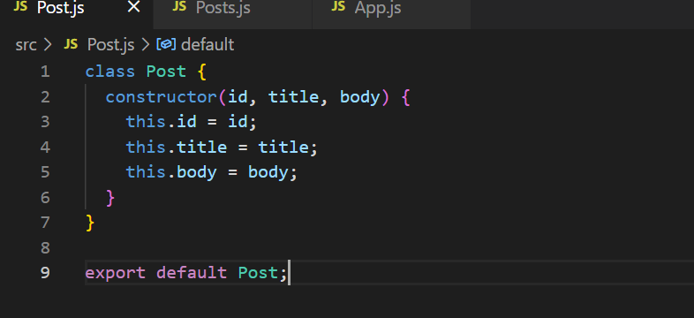

Posts.js

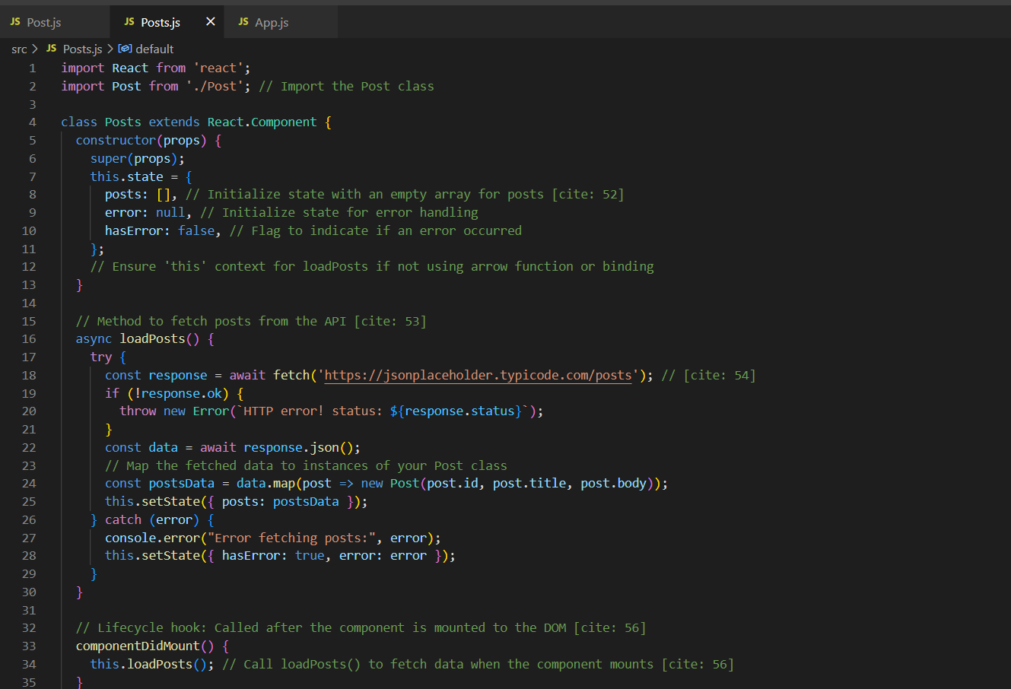

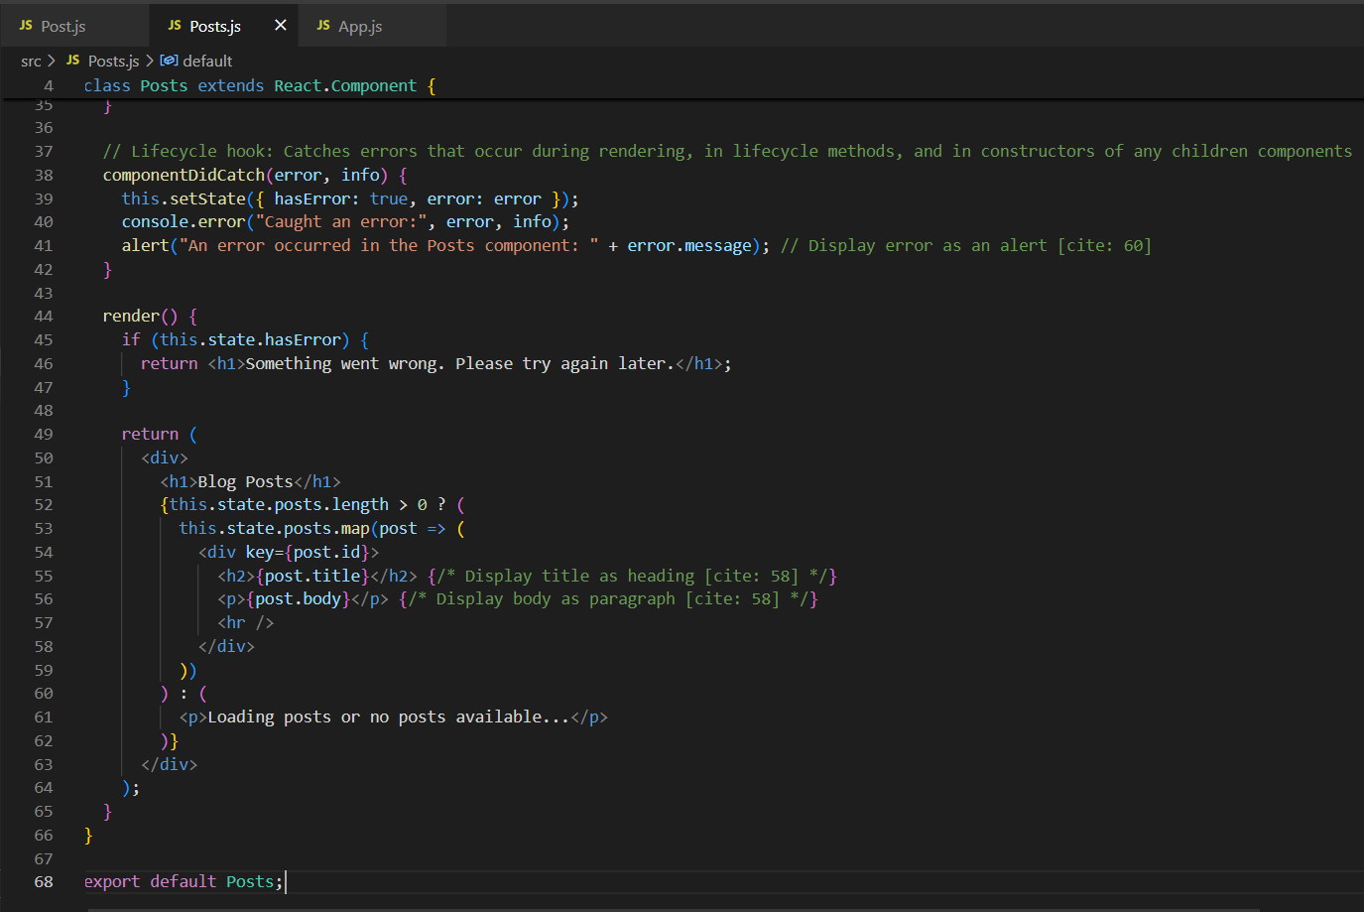

App.js

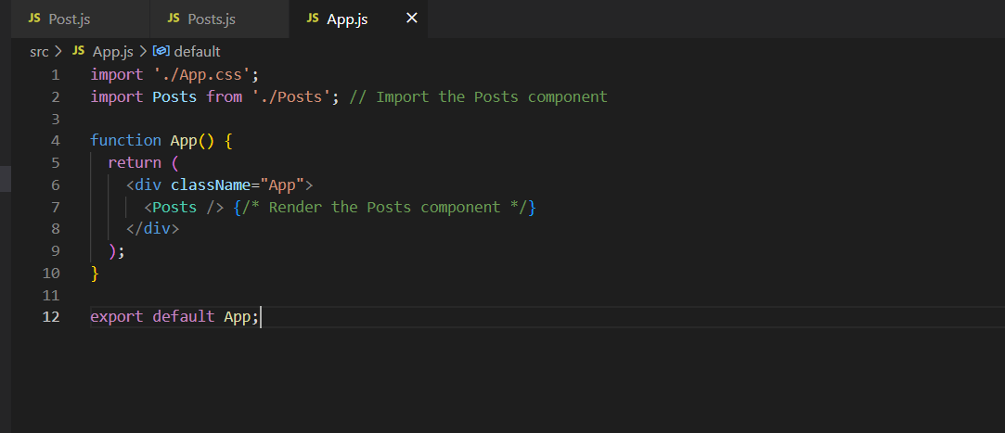

**Output:**

 